**Recommendations on setting up your file-store for Computer Science projects**

1. Using Visual Studio
   1. First stop using OneDrive (it doesn’t work well with Visual Studio and repositories)
   2. We are going to try using the H drive as this is available across College. If you end up using the C: drive, you will have to **clone** everytime you go to a different machine.
   3. Create a single folder to store your projects  e.g. H:\users\mbr\Respository
   4. Change the default location for your projects in Visual Studio as follows …….

In Visual Studio, go to Tools -> Options -> Projects and Solutions -> Locations

* 1. Set **Projects locations** to your C drive folder e.g. H:\users\mbr\Respository

Don't change the **User project templates location:** or **User item templates location:**

1. How to create a repository on GitHub

1. Go to <https://github.com/join>   and register with your email address (I would use a non-HSF email address so you can take it with you after college)
2. Go for the free account - don’t forget your password
3. "Start a Project"
4. Verify your email address

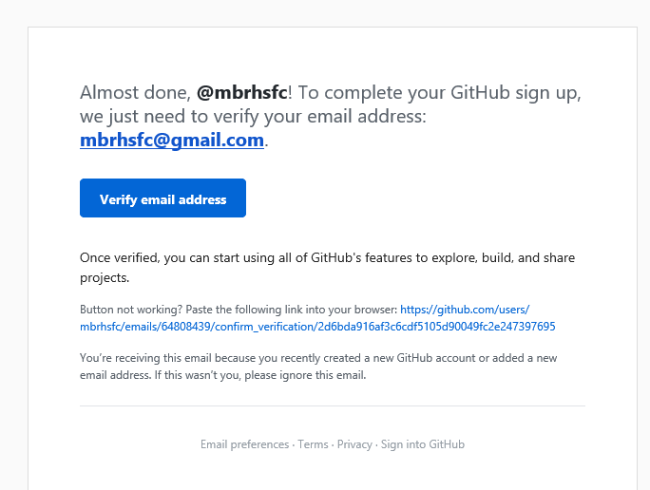

Now create your new repository on github as shown below

(This will be where your Master copies reside - they will then be downloaded to your home and college computer using the steps shown later)

Don’t forget the .ignore file

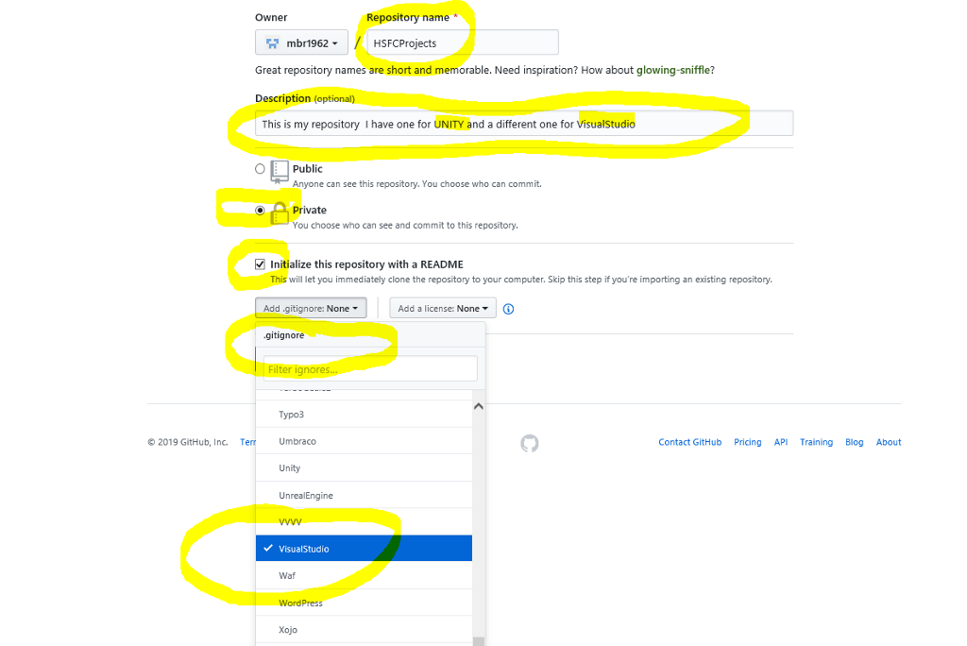

Don’t forget

If you are using the repository for VisualStudio  - choose that in the .gitignore - otherwise you will have hundreds of files copied

If you are using the repository for Unity  - choose that in the .gitignore  - otherwise you will have hundreds of files copied

DO NOT USE  the same repository for Unity and VisualStudio

Take a note of the name and path of your repository  - in my case it's  mbrhsfc/HSFCProjects

**Getting your existing files onto GitHub cloud**

**Log onto Github.com**

|  |  |
| --- | --- |
|  | Go to Upload (no more than 100 files at a time (that’s about 3 VS folders!)  Upload all your existing Visual Studio folders that you want in your repository |

**Setting up Visual Studio**

1. View TeamExplorer
2. **G**o to Manage Collections
3. Connect to GitHub

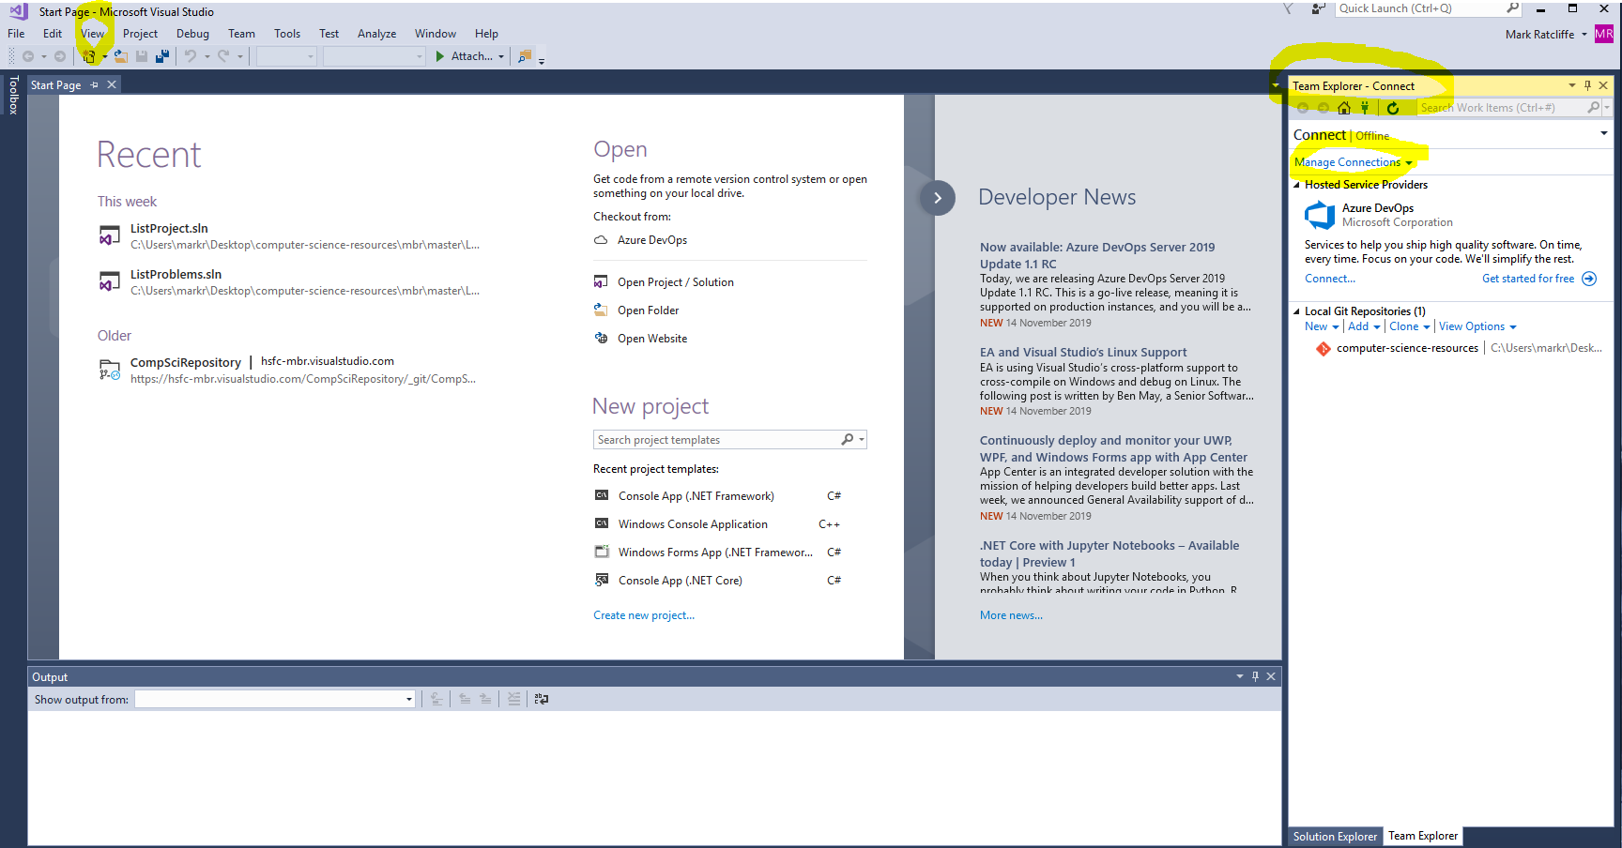

|  |  |
| --- | --- |
|  | If you don’t see GitHub, you will need to reinstall VisualStudio. I got the installer started within Visual Studio from Tools -> Get Tools and Features |

|  |  |
| --- | --- |
|  | If the reinstallation worked, you should now see GitHub |

|  |  |
| --- | --- |
|  | Log into GitHub |

|  |  |
| --- | --- |
|  | Choose your repository |

|  |  |
| --- | --- |
|  | In visual Studio, wherever you are (at home or college, hit clone to get a copy onto your current machine |

**If you have problems with lock, or if you forgot to set up the .gitignore file**

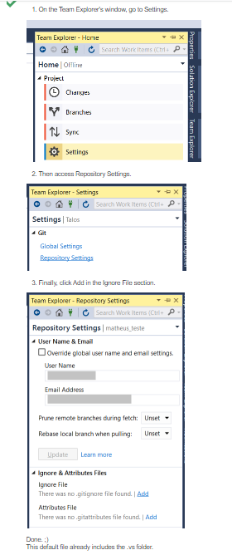

**Working with Visual Studio**

Once you have made changes to your code, when you look in the Solution View you will see indications of changes that have to be sent to the repository:

|  |  |
| --- | --- |
|  | Note the red tick showing that changes are pending |

|  |  |
| --- | --- |
|  |  |

|  |  |
| --- | --- |
|  | Now we need to commit our changes to the repository by hitting Commit |

|  |  |
| --- | --- |
|  | Enter a reason for the changes.  Hit commit |

|  |  |
| --- | --- |
|  | Now you have to sync!! |

|  |  |
| --- | --- |
|  | And finally, you have to push |

|  |  |
| --- | --- |
|  | Whenever you start coding again, either at home or college, you can then pull down the latest version by starting Visual Studio.   Click on Pull to make sure you have the latest version.  << Not yet shown in screendump>> |

**Applying the patch in College**

As we need to update things for College securities we occasionally have to run a patch.

To do this go to:

S:\Computing\3 Student Access - Read Only\

Mouse over **GitPatchVS** and hit run with Powershell

Enter S for Set proxy

Enter your college password

If you see any problems or suggestions with the above instructions, please email mbr@hereford.ac.uk